
Universal Review Analyzer
Customer Review Sentiment Dashboard
AI Bootcamp — May 2026
End-To-End Technology Programme
CAPACITI
ME NYATHI

Prepared by: Mbuyelo Nyathi

TABLE OF CONTENTS.

Table of Contents……………………………………………………………………..………..1
- Introduction………………………………………………………………………………....2
- System Overview……………………………………………………………………..…….2
- Dataset Role……………………………………………………………………………..…..2
- Demontsation of Outputs……………………………………………………………..…3
  - Sidebar with CSV upload and text input box………………………….3
  - Dataset overview with sample reviews and average rating……...4
  - Sentiment distribution bar chart…………………………………………4
  - Word cloud visualization…………………………………………………..5
  - Trend Analysis Graph………………………………………………………….5
  - Top reviews tab showing positive and negative examples…..…..6
- Challenges……………………………………………………………………………………7
- Risks……………………………………………………………………………………………7
- Lesson Learned…………………………………………………………………………….7
- Impact…………………………………………………………………………………………7
- Conclusion…………………………………………………………………………………..7

Documentation: Universal Review Analyzer

1. Introduction
The Universal Review Analyzer is a Streamlit-based dashboard application designed to analyze customer reviews from any dataset. It classifies reviews into Positive, Negative, or Neutral categories, generates word clouds of frequent terms, and identifies sentiment trends over time. The tool was initially tested using a McDonald’s reviews dataset, but it is capable of analyzing reviews from hotels, restaurants, places, products, or services. This flexibility makes it a universal solution for understanding customer sentiment across industries.

2. System Overview
The system was developed using Python and Streamlit, with NLTK VADER providing sentiment classification. Visualization libraries such as matplotlib and wordcloud were used to generate charts and word clouds. The dashboard features a modern dark theme with teal/orange accents and includes multiple tabs for different types of analysis:
- Dataset Overview: Displays sample reviews, total count, and average rating.
- Sentiment Analysis: Classifies reviews as Positive, Negative, or Neutral and shows distribution in a bar chart.
- Word Cloud: Highlights frequent terms in reviews.
- Trend Analysis: Shows sentiment changes over time if timestamps are available.
- Top Reviews: Displays the most positive and most negative reviews.

3. Dataset Role
The McDonald’s_Reviews.csv dataset was used as the initial proof-of-concept dataset. It provided realistic customer feedback for testing sentiment classification, visualizations, and trend analysis. While McDonald’s reviews were the starting point, the dashboard was designed to generalize to other datasets, such as hotel reviews, product feedback, or place reviews.

4. Demonstration of Outputs

  - Sidebar with CSV upload and text input box.
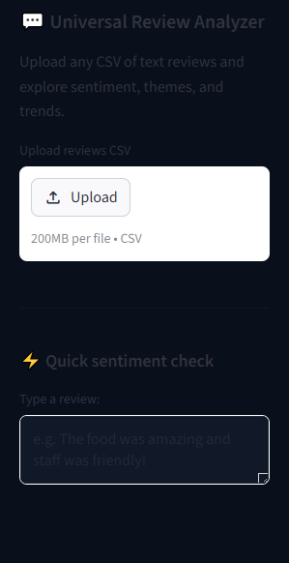

  - Dataset overview with sample reviews and average rating.
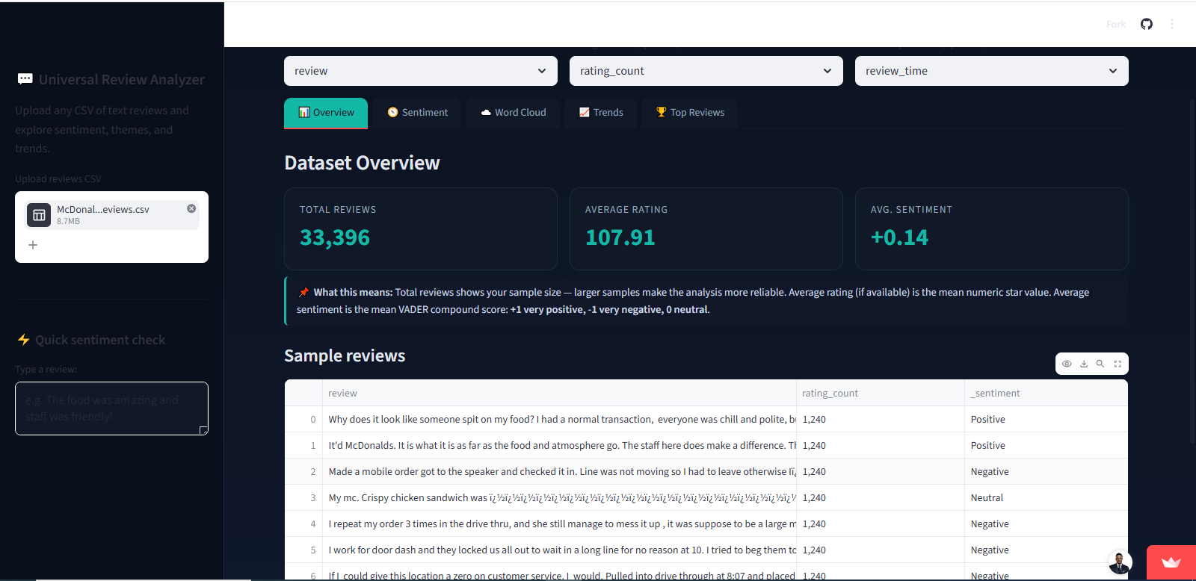

  - Sentiment distribution bar chart.
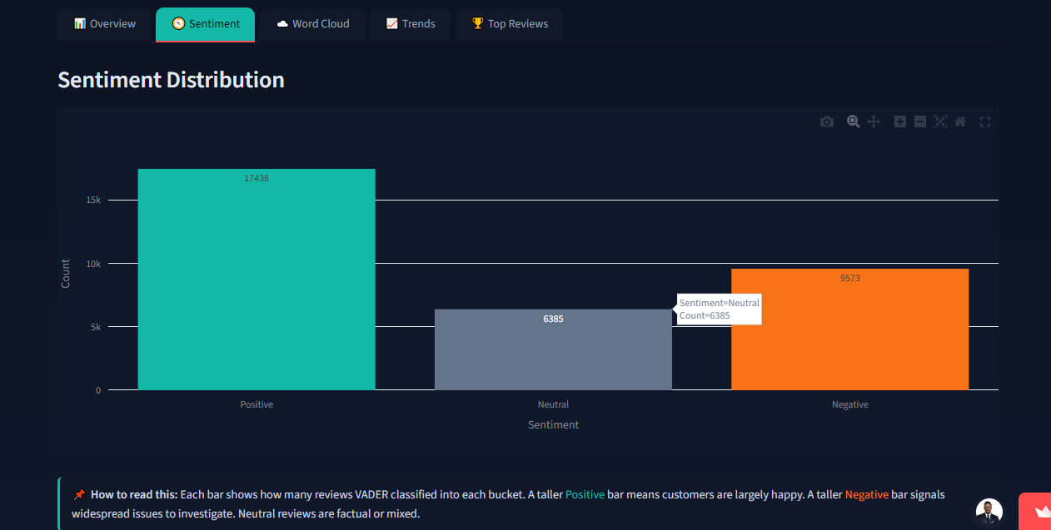

  - Word cloud visualization.
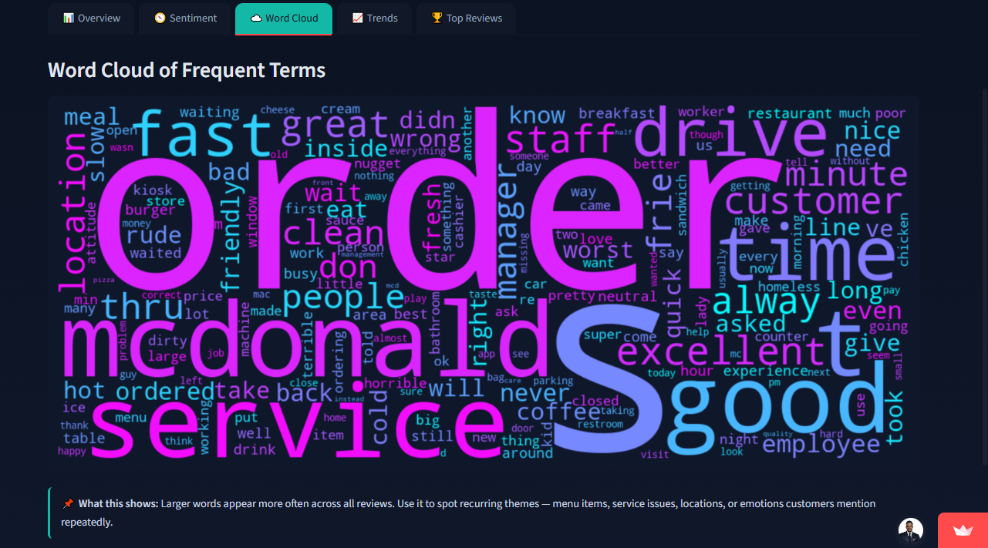
  - Trend analysis graph.
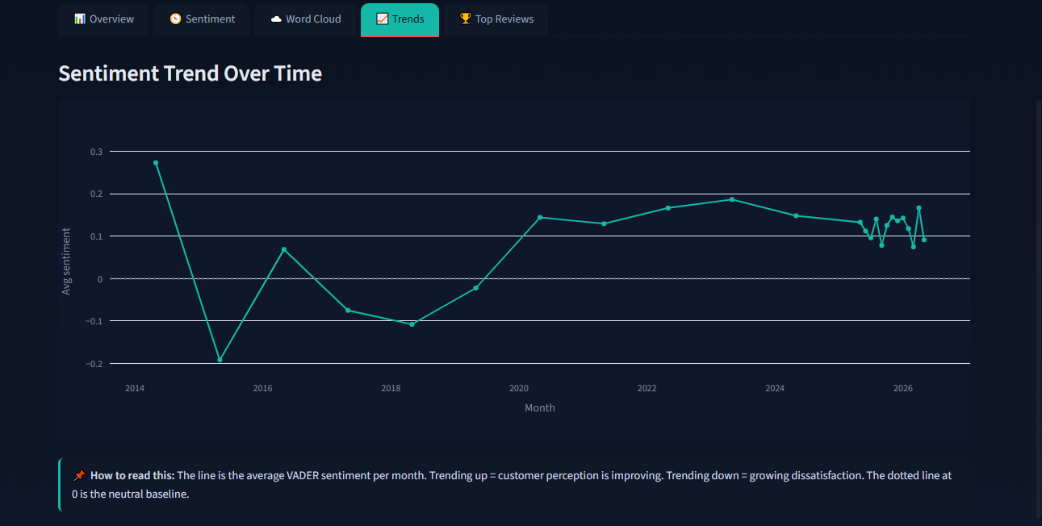

  - Top reviews tab showing positive and negative examples.
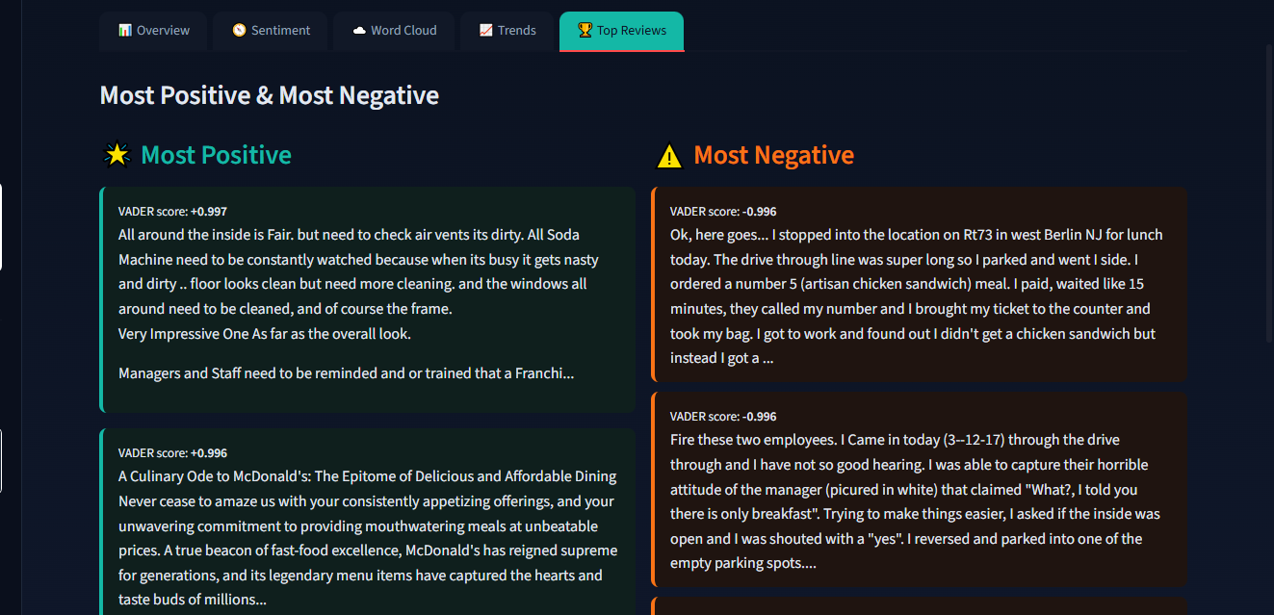
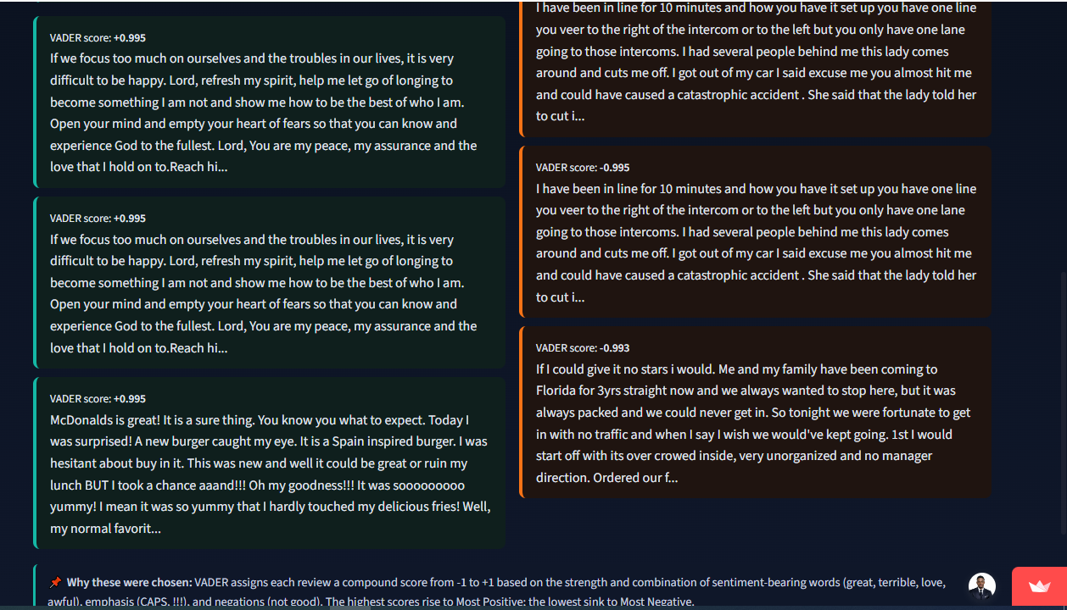

Challenges Faced
- Handling CSV encoding issues gracefully.
- Ensuring the analyzer generalized beyond the McDonald’s dataset.
- Designing a modern UI with multiple tabs.
- Managing time constraints within the bootcamp sprint.

6. Risks
- Misclassification of reviews due to sarcasm or ambiguous language.
- Over-reliance on VADER without domain-specific tuning.
- Data privacy concerns when uploading customer datasets.

7. Lessons Learned
- Visualization improves interpretability of sentiment analysis.
- Streamlit enables rapid prototyping but requires careful UI planning.
- Building dashboards requires balancing technical accuracy with user experience.
- AI tools are powerful but must be guided by human oversight.

8. Impact
The Universal Review Analyzer helps businesses and individuals quickly understand customer feedback. It saves time by automating sentiment classification and provides actionable insights through trends and top reviews. The project demonstrates applied AI skills and contributes to a professional portfolio suitable for industry showcase.

9. Conclusion
The Universal Review Analyzer highlights how AI can transform raw text data into meaningful insights. It combines sentiment analysis, visualization, and user-friendly design to deliver a professional tool that can be applied across industries. The inclusion of the McDonald’s dataset ensures reproducibility and credibility, while the system’s flexibility allows it to adapt to hotel reviews, place reviews, product feedback, or any other customer dataset.

